Dr. Sachchidanand Sinha
Indifference Curve
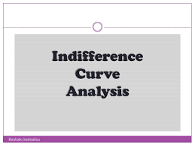
People cannot really put a numerical value on their level of satisfaction. However, they can, and do, identify what choices would give them more, or less, or the same amount of satisfaction. An indifference curve shows all combinations of goods that provide an equal level of utility or satisfaction.
For example, Figure 1 presents three indifference curves that represent Lilly’s preferences for the tradeoffs that she faces in her two main relaxation activities: eating doughnuts and reading paperback books. Each indifference curve (Ul, Um, and Uh) represents one level of utility. First we will explore the meaning of an individual indifference curve and then we will look at the relationship between different indifference curves.
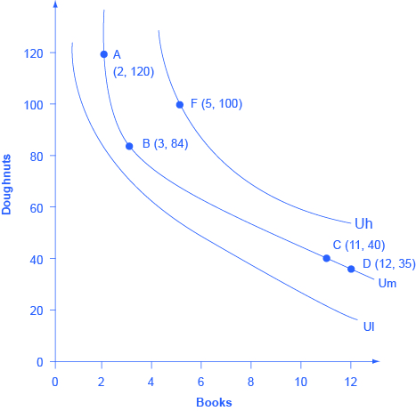
Figure 1. Lilly’s Indifference Curves. Lilly would receive equal utility from all combinations of books and doughnuts on a given indifference curve. Any points on the highest indifference curve Uh, like F, provide greater utility than any points like A, B, C, and D on the middle indifference curve Um. Similarly, any points on the middle indifference curve Um provide greater utility than any points on the lowest indifference curve Ul.

Shape of an Indifference Curve
The indifference curve Um has four points labeled on it: A, B, C, and D (see Figure 1). Since an indifference curve represents a set of choices that have the same level of utility, Lilly must receive an equal amount of utility, judged according to her personal preferences, from two books and 120 doughnuts (point A), from three books and 84 doughnuts (point B) from 11 books and 40 doughnuts (point C) or from 12 books and 35 doughnuts (point D). She would also receive the same utility from any of the unlabeled intermediate points along this indifference curve.
Indifference curves have a roughly similar shape in two ways: 1) they are downward sloping from left to right; 2) they are convex with respect to the origin. In other words, they are steeper on the left and flatter on the right. The downward slope of the indifference curve means that Lilly must trade off less of one good to get more of the other, while holding utility constant. For example, points A and B sit on the same indifference curve Um, which means that they provide Lilly with the same level of utility. Thus, the marginal utility that Lilly would gain from, say, increasing her consumption of books from two to three must be equal to the marginal utility that she would lose if her consumption of doughnuts was cut from 120 to 84—so that her overall utility remains unchanged between points A and B. Indeed, the slope along an indifference curve as the marginal rate of substitution, which is the rate at which a person is willing to trade one good for another so that utility will remain the same.
Indifference curves like Um are steeper on the left and flatter on the right. The reason behind this shape involves diminishing marginal utility—the notion that as a person consumes more of a good, the marginal utility from each additional unit becomes lower. Compare two different choices between points that all provide Lilly an equal amount of utility along the indifference curve Um: the choice between A and B, and between C and D. In both choices, Lilly consumes one more book, but between A and B her consumption of doughnuts falls by 36 (from 120 to 84) and between C and D it falls by only five (from 40 to 35). The reason for this difference is that points A and C are different starting points, and thus have different implications for marginal utility. At point A, Lilly has few books and many doughnuts. Thus, her marginal utility from an extra book will be relatively high while the marginal utility of additional doughnuts is relatively low—so on the margin, it will take a relatively large number of doughnuts to offset the utility from the marginal book. At point C, however, Lilly has many books and few doughnuts. From this starting point, her marginal utility gained from extra books will be relatively low, while the marginal utility lost from additional doughnuts would be relatively high—so on the margin, it will take a relatively smaller number of doughnuts to offset the change of one marginal book. In short, the slope of the indifference curve changes because the marginal rate of substitution—that is, the quantity of one good that would be traded for the other good to keep utility constant—also changes, as a result of diminishing marginal utility of both goods.

Field of Indifference Curves
Each indifference curve represents the choices that provide a single level of utility. Every level of utility will have its own indifference curve. Thus, Lilly’s preferences will include an infinite number of indifference curves lying nestled together on the diagram—even though only three of the indifference curves, representing three levels of utility, appear in Figure 1. In other words, an infinite number of indifference curves are not drawn on this diagram—but you should remember that they exist.
Higher indifference curves represent a greater level of utility than lower ones. In Figure 1, indifference curve Ul can be thought of as a “low” level of utility, while Um is a “medium” level of utility and Uh is a “high” level of utility. All of the choices on indifference curve Uh are preferred to all of the choices on indifference curve Um, which in turn are preferred to all of the choices on Ul.

Individuality of Indifference Curves
Each person determines his or her own preferences and utility. Thus, while indifference curves have the same general shape—they slope down, and the slope is steeper on the left and flatter on the right—the specific shape of indifference curves can be different for every person. Figure 1, for example, applies only to Lilly’s preferences. Indifference curves for other people would probably travel through different points.
People seek the highest level of utility, which means that they wish to be on the highest possible indifference curve. However, people are limited by their budget constraints, which show what tradeoffs are actually possible. The solution to this problem, i.e. the combination of goods and services that will maximize an individual’s total utility given their budget, is called the consumer equilibrium
Return to the situation of Lilly’s choice between paperback books and doughnuts. Say that books cost $6, doughnuts are 50 cents each, and that Lilly has $60 to spend. This information provides the basis for the budget line shown in Figure 1. Along with the budget line are shown the three indifference curves from Figure 1. What is Lilly’s utility-maximizing choice? Several possibilities are identified in the diagram.
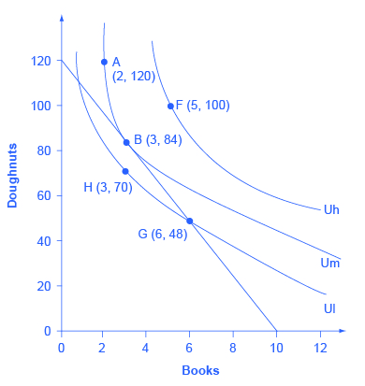
Figure 2. Indifference Curves and a Budget Constraint. Lilly’s preferences are shown by the indifference curves. Lilly’s budget constraint, given the prices of books and doughnuts and her income, is shown by the straight line. Lilly’s optimal choice will be point B, where the budget line is tangent to the indifference curve Um. Lilly would have more utility at a point like F on the higher indifference curve Uh, but the budget line does not touch the higher indifference curve Uh at any point, so she cannot afford this choice. A choice like G is affordable to Lilly, but it lies on indifference curve Ul and thus provides less utility than choice B, which is on indifference curve Um.
The choice of F with five books and 100 doughnuts is highly desirable, since it is on the highest indifference curve Uh of those shown in the diagram. However, it is not affordable given Lilly’s budget constraint. The choice of H with three books and 70 doughnuts on indifference curve Ul is a wasteful choice, since it is inside Lilly’s budget set, and as a utility-maximizer, Lilly will always prefer a choice on the budget constraint itself. Choices B and G are both on the opportunity set. However, choice G of six books and 48 doughnuts is on lower indifference curve Ul than choice B of three books and 84 doughnuts, which is on the indifference curve Um. If Lilly were to start at choice G, and then thought about whether the marginal utility she was deriving from doughnuts and books, she would decide that some additional doughnuts and fewer books would make her happier—which would cause her to move toward her preferred choice B. Given the combination of Lilly’s personal preferences, as identified by her indifference curves, and Lilly’s opportunity set, which is determined by prices and income, B will be her utility-maximizing choice.

